Our Senior Management Team

Ian Loynes - Chief Executive

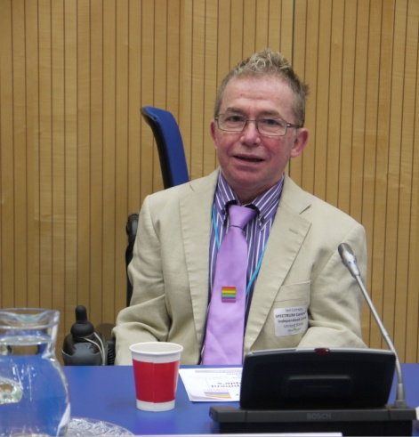
Ian originally joined SPECTRUM to develop our Direct Payments Support Services. He took on the Chief Executive role in 1998. He ran his own Computer Consultancy business for 15 years before joining SPECTRUM.

Ian is actively involved with several other organisations controlled by Disabled People, including Disability Rights UK. He has served on a number of influential bodies, locally and nationally, and co-founded the South East Network of Disabled People’s Organisations.

Ian says:

"I am evangelical about the Social Model of Disability, the importance of a strong and vibrant Disability Movement, and the development of User Led Organisations. I see these as tools to enable the emancipation of Disabled People from the daily discrimination and oppression they face. I am a strong supporter of the move away from Disabled People’s traditional reliance and association with ‘charity’, being viewed as objects of pity and inflexible institutional based service provision."

Lesley Long-Price - Office Manager
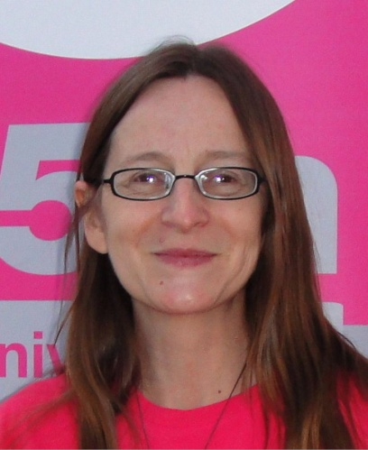
Lesley joined SPECTRUM in 1998 as a volunteer in the role of Management Committee minute taker. In April 2000 she became a paid member of staff working as Administration Assistant to the Chief Executive and to the Consumer Audit Project. After several promotions Lesley is now the Office Manager. Lesley originally came from a health background where she trained and worked as a Registered General Nurse.

Lesley says:

“My personal experience of working at SPECTRUM is of an organisation that takes Disabled People along a journey of discovery in the world of Disability. SPECTRUM is all about people, those who work and volunteer, service users we support and our wider stakeholders on a local and regional level and those we attempt to influence on a national political level. I believe that without organisations like SPECTRUM and those that are run and controlled by their constituents that the world would be more unjust, more unequal, less understood and less informed, about the lived experience of being a Disabled Person.”

Gerry Zarb - Business Development and Policy Manager

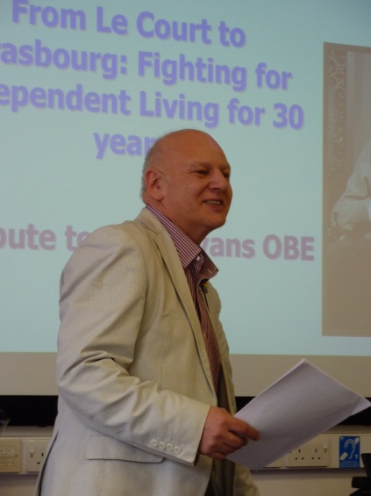
Gerry joined SPECTRUM in 2012 to work on our User Led Organisations project. He took on the Business Development role towards the end of 2013. Gerry is former Head of Human Rights in the Public Sector at the Equality and Human Rights Commission (EHRC). He has also been Head of Health and Social Care at both the EHRC and at the Disability Rights Commission and Disability Programme Director at the Policy Studies Institute from 1992 to 2001.

He has extensive research and consultancy experience in the areas of disability equality, with a particular interest in care and support, and has published widely on issues such human rights, direct payments, advocacy, the economics of independent living, employment and training, disability benefits, ageing and disability, and disability discrimination.

Gerry says:

"My personal belief in SPECTRUM’s aims is deeply rooted and is based on both an objective evaluation of the social and economic costs of Disabled People’s exclusion from key areas of social, cultural and economic life, as well as my own personal experience of discrimination. I have always believed that the most effective challenge to such exclusion must be based on robust evidence, rational argument and offering solutions. I am passionate about finding practical solutions to the barriers we face and helping others to recognise what they can do to help in a constructive way."

